Packet Tracer – Skills Integration Challenge
Topology
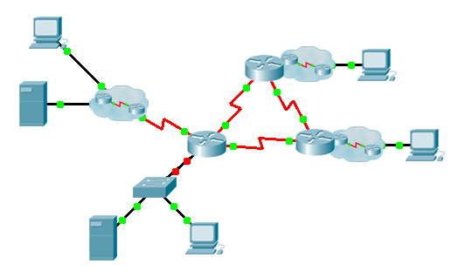

Addressing Table

Device | Interface | IP Address | Subnet Mask | Default Gateway
 | G0/0.15 |  |  | N/A
 | G0/0.30 |  |  | N/A
 | G0/0.45 |  |  | N/A
 | G0/0.60 |  |  | N/A
 | S0/0/0 |  | 255.255.255.252 | N/A
 | S0/0/1 |  | 255.255.255.252 | N/A
 | S0/1/0 |  | 255.255.255.252 | N/A
 | G0/0 |  |  | N/A
 | S0/0/0 |  | 255.255.255.252 | N/A
 | S0/0/1 |  | 255.255.255.252 | N/A
 | G0/0 |  |  | N/A
 | S0/0/0 |  | 255.255.255.252 | N/A
 | S0/0/1 |  | 255.255.255.252 | N/A
 | VLAN 60
 | NIC | DHCP Assigned | DHCP Assigned | DHCP Assigned
VLANs and Port Assignments Table
VLAN Number - Name | Port assignment | Network
15 - Servers | F0/11 - F0/20
30 - PCs | F0/1 - F0/10
45 - Native | G0/1
60 - Management | VLAN 60
Scenario
This culminating activity includes many of the skills that you have acquired during this course. First, you will complete the documentation for the network. Make sure you have a printed version of the instructions. During implementation, you will configure VLANs, trunking, port security and SSH remote access on a switch. You will then implement inter-VLAN routing and NAT on a router. Finally, you will use your documentation to verify your implementation by testing end-to-end connectivity.
Documentation
You are required to fully document the network. You will need a print out of this instruction set, which will include an unlabeled topology diagram:
Label all the device names, network addresses and other important information that Packet Tracer generated.
Complete the Addressing Table and VLANs and Port Assignments Table.
Fill in any blanks in the Implementation and Verification steps. The information is supplied when you launch the Packet Tracer activity.
Implementation
Note: All devices in the topology except [[R1Name]], [[S1Name]], and [[PC1Name]] are fully configured. You do not have access to the other routers. You can access all the servers and PCs for testing purposes.
Implement to following requirements using your documentation:
[[S1Name]]
- Configure remote management access including IP addressing and SSH:
Domain is cisco.com
User [[UserText]] with password [[UserPass]]
Crypto key length of 1024
SSH version 2, limited to 2 authentication attempts and a 60 second timeout
Clear text passwords should be encrypted.
- Configure, name and assign VLANs. Ports should be manually configured as access ports.
- Configure trunking.
- Implement port security:
On Fa0/1, allow 2 MAC addresses that are automatically added to the configuration file when detected. The port should not be disabled, but a syslog message should be captured if a violation occurs.
Disable all other unused ports.
[[R1Name]]
- Configure inter-VLAN routing.
- Configure DHCP services for VLAN 30. Use LAN as the case-sensitive name for the pool.
- Implement routing:
Use RIPv2 as the routing protocol.
Configure one network statement for the entire [[DisplayNet]] address space.
Disable interfaces that should not send RIPv2 messages.
Configure a default route to the Internet.
- Implement NAT:
Configure a standard, one statement ACL number 1. All IP addresses belonging to the [[DisplayNet]] address space are allowed.
Refer to your documentation and configure static NAT for the File Server.
Configure dynamic NAT with PAT using a pool name of your choice, a /30 mask, and these two public addresses:
[[NATPoolText]]
[[PC1Name]]
Verify [[PC1Name]] has received full addressing information from [[R1Name]].
Verification
All devices should now be able to ping all other devices. If not, troubleshoot your configurations to isolate and solve problems. A few tests include:
- Verify remote access to [[S1Name]] by using SSH from a PC.
- Verify VLANs are assigned to appropriate ports and port security is in force.
- Verify OSPF neighbors and a complete routing table.
- Verify NAT translations and statics.
Outside Host should be able to access File Server at the public address.
Inside PCs should be able to access Web Server.
- Document any problems you encountered and the solutions in the Troubleshooting Documentation table below.
Troubleshooting Documentation
Problem | Solution
Suggested Scoring Rubric
Packet Tracer scores 70 points. Documentation is worth 30 points.

