Packet Tracer – Skills Integration Challenge
Topology
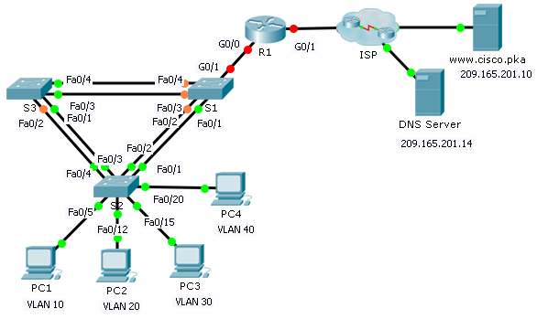
Addressing Table
Device | Interface | IP Address | Subnet Mask | Default Gateway
R1 | G0/0.10 | 172.31.10.1 | 255.255.255.224 | N/A
 | G0/0.20 | 172.31.20.1 | 255.255.255.240 | N/A
 | G0/0.30 | 172.31.30.1 | 255.255.255.128 | N/A
 | G0/0.40 | 172.31.40.1 | 255.255.255.192 | N/A
 | G0/1 | DHCP Assigned | DHCP Assigned | N/A
PC1 | NIC | DHCP Assigned | DHCP Assigned | DHCP Assigned
PC2 | NIC | DHCP Assigned | DHCP Assigned | DHCP Assigned
PC3 | NIC | DHCP Assigned | DHCP Assigned | DHCP Assigned
PC4 | NIC | DHCP Assigned | DHCP Assigned | DHCP Assigned

VLAN Port Assignments and DHCP Information
Ports | VLAN Number - Name | DHCP Pool Name | Network
Fa0/5 – 0/9 | VLAN 10 - Sales | VLAN_10 | 172.31.10.0/27
Fa0/10 – Fa0/14 | VLAN 20 - Production | VLAN_20 | 172.31.20.0/28
Fa0/15 – Fa0/19 | VLAN 30 - Marketing | VLAN_30 | 172.31.30.0/25
Fa0/20 - Fa0/24 | VLAN 40 - HR | VLAN_40 | 172.31.40.0/26
Scenario
In this culminating activity, you will configure VLANs, trunks, DHCP Server, DHCP relay agents, and configure a router as a DHCP client.
Requirements
Using the information in the tables above, implement the following requirements:
- Create VLANs on S2 and assign VLANs to appropriate ports. Names are case-sensitive
- Configure S2 ports for trunking.
- Configure all non-trunk ports on S2 as access ports.
- Configure R1 to route between VLANs. Subinterface names should match the VLAN number.
- Configure R1 to act as a DHCP server for the VLANs attached to S2.
Create a DHCP pool for each VLAN. Names are case-sensitive.
Assign the appropriate addresses to each pool.
Configure DHCP to provide the default gateway address
Configure the DNS server 209.165.201.14 for each pool.
Prevent the first 10 addresses from each pool from being distributed to end devices.
- Verify that each PC has an address assigned from the correct DHCP pool.
Note: DHCP address assignments may take some time. Click Fast Forward Time to speed up the process.
- Configure R1 as a DHCP client so that it receives an IP address from the ISP network.
- Verify all devices can now ping each other and www.cisco.pka.

