Packet Tracer – Implementing Static and Dynamic NAT
Topology
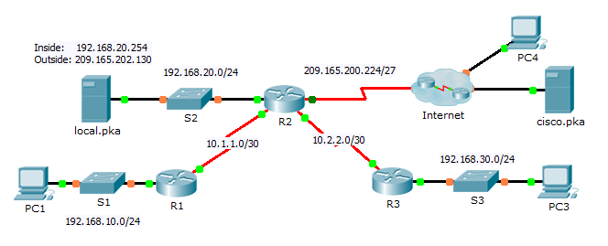
Objectives
Part 1: Configure Dynamic NAT with PAT
Part 2: Configure Static NAT
Part 3: Verify NAT Implementation
- Configure Dynamic NAT with PAT
  - Configure traffic that will be permitted for NAT translations.
On R2, configure a standard ACL named R2NAT that uses three statements to permit, in order, the following private address spaces:192.168.10.0/24, 192.168.20.0/24, and 192.168.30.0/24.
  - Configure a pool of addresses for NAT.
Configure R2 with a NAT pool named R2POOL that uses the first address in the 209.165.202.128/30 address space. The second address is used for static NAT later in Part 2.
  - Associate the named ACL with the NAT pool and enable PAT.
  - Configure the NAT interfaces.
Configure R2 interfaces with the appropriate inside and outside NAT commands.
- Configure Static NAT
Refer to the Topology. Create a static NAT translation to map the local.pka inside address to its outside address.
- Verify NAT Implementation
  - Access services across the Internet.
    - From the web browser of PC1, or PC3, access the web page for cisco.pka.
    - From the web browser for PC4, access the web page for local.pka.
  - View NAT translations.
View the NAT translations on R2.
R2# show ip nat translations

