Packet Tracer - Troubleshooting Static Routes
Topology
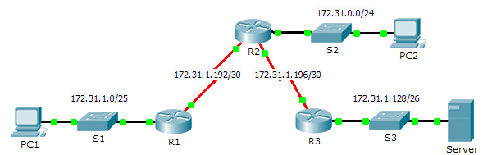
Addressing Table
Device | Interface | IPv4 Address | Subnet Mask | Default Gateway
R1 | G0/0 | 172.31.1.1 | 255.255.255.128 | N/A
 | S0/0/0 | 172.31.1.194 | 255.255.255.252 | N/A
R2 | G0/0 | 172.31.0.1 | 255.255.255.0 | N/A
 | S0/0/0 | 172.31.1.193 | 255.255.255.252 | N/A
 | S0/0/1 | 172.31.1.197 | 255.255.255.252 | N/A
R3 | G0/0 | 172.31.1.129 | 255.255.255.192 | N/A
 | S0/0/1 | 172.31.1.198 | 255.255.255.252 | N/A
PC1 | NIC | 172.31.1.126 | 255.255.255.128 | 172.31.1.1
PC2 | NIC | 172.31.0.254 | 255.255.255.0 | 172.31.0.1
Server | NIC | 172.31.1.190 | 255.255.255.192 | 172.31.1.129
Objectives
Part 1: Locate the Problem
Part 2: Determine the Solution
Part 3: Implement the Solution
Part 4: Verify That the Issue Is Resolved
Background
In this activity, PC1 reports that they cannot access resources on the server. Locate the problem, decide on an appropriate solution and resolve the issue.
- Locate the Problem
PC1 cannot access files on the server. Locate the problem using the appropriate show commands on all routers and any troubleshooting commands on the PCs that you have learned from previous chapters.
What are some of the troubleshooting commands on routers and PCs that can be used to identify the source of the problem?
_______________________________________________________________________________________
- Determine the Solution
After you have located the problem that is preventing PC1 from accessing files on the server, fill in the table below.
Problem | Solution
- Implement the Solution
    - If there are any misconfigured static routes, you must remove them before the correct ones can be added to the configuration.
    - Add any missing static routes by configuring directly attached routes.
- Verify That the Issue Is Resolved
    - Ping from PC1 to the server.
    - Open a web connection to the server. After you correctly identify and implement the correct solution to the problem, you will receive a message in the web browser when you connect to the server.
Suggested Scoring Rubric
Activity Section | Possible Points | Earned Points
Part 1: Locate the Problem | 2
Part 2: Determine the Solution | 8
Packet Tracer Score | 90
Total Score | 100

