Packet Tracer - Configuring Named IPv4 Standard ACLs
Topology
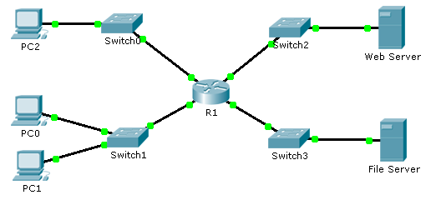
Addressing Table
Device | Interface | IP Address | Subnet Mask | Default Gateway
R1 | F0/0 | 192.168.10.1 | 255.255.255.0 | N/A
 | F0/1 | 192.168.20.1 | 255.255.255.0 | N/A
 | E0/0/0 | 192.168.100.1 | 255.255.255.0 | N/A
 | E0/1/0 | 192.168.200.1 | 255.255.255.0 | N/A
File Server | NIC | 192.168.200.100 | 255.255.255.0 | 192.168.200.1
Web Server | NIC | 192.168.100.100 | 255.255.255.0 | 192.168.100.1
PC0 | NIC | 192.168.20.3 | 255.255.255.0 | 192.168.20.1
PC1 | NIC | 192.168.20.4 | 255.255.255.0 | 192.168.20.1
PC2 | NIC | 192.168.10.3 | 255.255.255.0 | 192.168.10.1
Objectives
Part 1: Configure and Apply a Named Standard ACL
Part 2: Verify the ACL Implementation
Background / Scenario
The senior network administrator has tasked you to create a standard named ACL to prevent access to a file server. All clients from one network and one specific workstation from a different network should be denied access.
- Configure and Apply a Named Standard ACL
  - Verify connectivity before the ACL is configured and applied.
All three workstations should be able to ping both the Web Server and File Server.
  - Configure a named standard ACL.
Configure the following named ACL on R1.
R1(config)# ip access-list standard File_Server_Restrictions
R1(config-std-nacl)# permit host 192.168.20.4
R1(config-std-nacl)# deny any
Note: For scoring purposes, the ACL name is case-sensitive.
  - Apply the named ACL.
    - Apply the ACL outbound on the interface Fast Ethernet 0/1.
R1(config-if)# ip access-group File_Server_Restrictions out
    - Save the configuration.
- Verify the ACL Implementation
  - Verify the ACL configuration and application to the interface.
Use the show access-lists command to verify the ACL configuration. Use the show run or show ip interface fastethernet 0/1 command to verify that the ACL is applied correctly to the interface.
  - Verify that the ACL is working properly.
All three workstations should be able to ping the Web Server, but only PC1 should be able to ping the File Server.

