Packet Tracer – Skills Integration Challenge
Topology
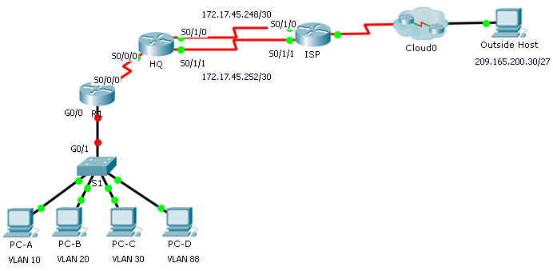
Addressing Table
Device | Interface | IP Address | Subnet Mask | Default Gateway | VLAN
R1 | S0/0/0 | 172.31.1.2 | 255.255.255.0 | N/A | N/A
 | G0/0.10 | 172.31.10.1 | 255.255.255.0 | N/A | 10
 | G0/0.20 | 172.31.20.1 | 255.255.255.0 | N/A | 20
 | G0/0.30 | 172.31.30.1 | 255.255.255.0 | N/A | 30
 | G0/0.88 | 172.31.88.1 | 255.255.255.0 | N/A | 88
 | G0/0.99 | 172.31.99.1 | 255.255.255.0 | N/A | 99
S1 | VLAN 88 | 172.31.88.33 | 255.255.255.0 | 172.31.88.1 | 88
PC-A | NIC | 172.31.10.21 | 255.255.255.0 | 172.31.10.1 | 10
PC-B | NIC | 172.31.20.22 | 255.255.255.0 | 172.31.20.1 | 20
PC-C | NIC | 172.31.30.23 | 255.255.255.0 | 172.31.30.1 | 30
PC-D | NIC | 172.31.88.24 | 255.255.255.0 | 172.31.88.1 | 88
VLAN Table
VLAN | Name | Interfaces
10 | Sales | F0/11-15
20 | Production | F0/16-20
30 | Marketing | F0/5-10
88 | Management | F0/21-24
99 | Native | G0/1
Scenario
In this activity, you will demonstrate and reinforce your ability to configure routers for inter-VLAN communication and configure static routes to reach destinations outside of your network. Among the skills you will demonstrate are configuring inter-VLAN routing, static and default routes.
Requirements
- Configure inter-VLAN routing on R1 based on the Addressing Table.
- Configure trunking on S1.
- Configure four directly attached static route on HQ to each VLANs 10, 20, 30 and 88.
- Configure directly attached static routes on HQ to reach Outside Host.
Configure the primary path through the Serial 0/1/0 interface.
Configure the backup route through the Serial 0/1/1 interface with a 10 AD.
- Configure a directly attached default route on R1.
- Verify connectivity by making sure all the PCs can ping Outside Host.

