Packet Tracer – Configuring Dynamic NAT
Topology
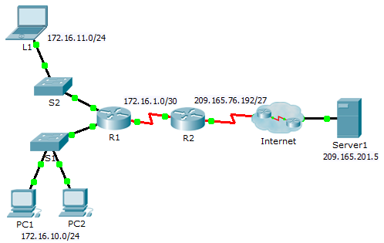
Objectives
Part 1: Configure Dynamic NAT
Part 2: Verify NAT Implementation
- Configure Dynamic NAT
  - Configure traffic that will be permitted.
On R2, configure one statement for ACL 1 to permit any address belonging to 172.16.0.0/16.
  - Configure a pool of address for NAT.
Configure R2 with a NAT pool that uses all four addresses in the 209.165.76.196/30 address space.
Notice in the topology there are 3 network ranges that would be translated based on the ACL created. What will happen if more than 2 devices attempt to access the Internet?
_______________________________________________________________________________________
_______________________________________________________________________________________
  - Associate ACL1 with the NAT pool.
  - Configure the NAT interfaces.
Configure R2 interfaces with the appropriate inside and outside NAT commands.
- Verify NAT Implementation
  - Access services across the Internet.
From the web browser of L1, PC1, or PC2, access the web page for Server1.
  - View NAT translations.
View the NAT translations on R2.
R2# show ip nat translations

