Packet Tracer - Configuring IPv6 Static and Default Routes
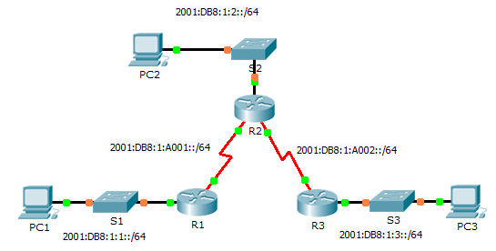
IPv6 Addressing Table
Device | Interface | IPv6 Address/Prefix | Default Gateway
R1 | G0/0 | 2001:DB8:1:1::1/64 | N/A
 | S0/0/0 | 2001:DB8:1:A001::1/64 | N/A
R2 | G0/0 | 2001:DB8:1:2::1/64 | N/A
 | S0/0/0 | 2001:DB8:1:A001::2/64 | N/A
 | S0/0/1 | 2001:DB8:1:A002::1/64 | N/A
R3 | G0/0 | 2001:DB8:1:3::1/64 | N/A
 | S0/0/1 | 2001:DB8:1:A002::2/64 | N/A
PC1 | NIC | 2001:DB8:1:1::F/64 | FE80::1
PC2 | NIC | 2001:DB8:1:2::F/64 | FE80::2
PC3 | NIC | 2001:DB8:1:3::F/64 | FE80::3
Objectives
Part 1: Examine the Network and Evaluate the Need for Static Routing
Part 2: Configure IPv6 Static and Default Routes
Part 3: Verify Connectivity
Background
In this activity, you will configure IPv6 static and default routes. A static route is a route that is entered manually by the network administrator in order to create a route that is reliable and safe. There are four different static routes used in this activity: a recursive static route; a directly attached static route; a fully specified static route; and a default route.
- Examine the Network and Evaluate the Need for Static Routing
    - Looking at the topology diagram, how many networks are there in total? ______________
    - How many networks are directly connected to R1, R2, and R3? _________________________________
    - How many static routes are required by each router to reach networks that are not directly connected?
____________________________________________________________________________________
____________________________________________________________________________________
    - Which command is used to configure IPv6 static routes?
____________________________________________________________________________________
- Configure IPv6 Static and Default Routes
  - Enable IPv6 routing on all routers.
Before configuring static routes, we must configure the router to forward IPv6 packets
Which command accomplishes this? ________________________________
Enter this command on each router.
  - Configure recursive static routes on R1.
Configure an IPv6 recursive static route to every network not directly connected to R1.
  - Configure a directly attached and a fully specified static route on R2.
    - Configure a directly attached static route from R2 to the R1 LAN.
    - Configure a fully specific route from R2 to the R3 LAN.
Note: Packet Tracer v6.0.1 only checks for directly attached and recursive static routes. Your instructor may ask to review your configuration of a fully specified IPv6 static route.
  - Configure a default route on R3.
Configure a recursive default route on R3 to reach all networks not directly connected.
  - Verify static route configurations.
    - Which command is used in Packet Tracer to verify the IPv6 configuration of a PC from the command prompt?
____________________________________________________________________________________
    - Which command displays the IPv6 addresses configured on a router's interface?
____________________________________________________________________________________
    - Which command displays the contents of the IPv6 routing table? ________________________________
- Verify Network Connectivity
Every device should now be able to ping every other device. If not, review your static and default route configurations.
Suggested Scoring Rubric
Activity Section | Question Location | Possible Points | Earned Points
Part 1: Exam the Network and Evaluate the Need for Static Routing | a - d | 20
Part 1 Total |  | 20
Part 2: Configure IPv6 Static and Default Routes | Step 1 | 5
 | Step 5 | 15
Part 2 Total |  | 20
Packet Tracer Score |  | 60
Total Score |  | 100

