Packet Tracer - Configuring DHCP Using Cisco IOS
Topology
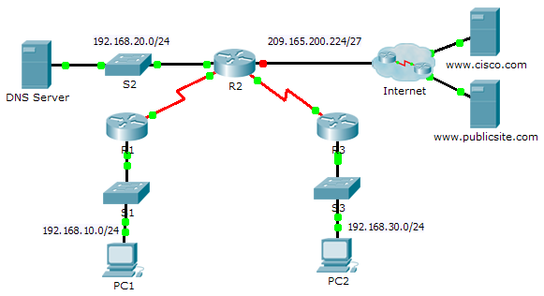
Addressing Table
Device | Interface | IPv4 Address | Subnet Mask | Default Gateway
R1 | G0/0 | 192.168.10.1 | 255.255.255.0 | N/A
 | S0/0/0 | 10.1.1.1 | 255.255.255.252 | N/A
R2 | G0/0 | 192.168.20.1 | 255.255.255.0 | N/A
 | G0/1 | DHCP Assigned | DHCP Assigned | N/A
 | S0/0/0 | 10.1.1.2 | 255.255.255.252 | N/A
 | S0/0/1 | 10.2.2.2 | 255.255.255.252 | N/A
R3 | G0/0 | 192.168.30.1 | 255.255.255.0 | N/A
 | S0/0/1 | 10.2.2.1 | 255.255.255.0 | N/A
PC1 | NIC | DHCP Assigned | DHCP Assigned | DHCP Assigned
PC2 | NIC | DHCP Assigned | DHCP Assigned | DHCP Assigned
DNS Server | NIC | 192.168.20.254 | 255.255.255.0 | 192.168.20.1
Objectives
Part 1: Configure a Router as a DHCP Server
Part 2: Configure DHCP Relay
Part 3: Configure a Router as a DHCP Client
Part 4: Verify DHCP and Connectivity
Scenario
A dedicated DHCP server is scalable and relatively easy to manage, but can be costly to have one at every location in a network. However, a Cisco router can be configured to provide DHCP services without the need for a dedicated server. As the network technician for your company, you are tasked with configuring a Cisco router as a DHCP server to provide dynamic allocation of addresses to clients on the network. You are also required to configure the edge router as a DHCP client so that it receives an IP address from the ISP network.
- Configure a Router as a DHCP Server
  - Configure the excluded IPv4 addresses.
Configure R2 to exclude the first 10 addresses from the R1 and R3 LANs. All other addresses should be available in the DHCP address pool.
  - Create a DHCP pool on R2 for the R1 LAN.
    - Create a DHCP pool named R1-LAN (case-sensitive).
    - Configure the DHCP pool to include the network address, the default gateway, and the IP address of the DNS server.
  - Create a DHCP pool on R2 for the R3 LAN.
    - Create a DHCP pool named R3-LAN (case-sensitive).
    - Configure the DHCP pool to include the network address, the default gateway, and the IP address of the DNS server.
- Configure DHCP Relay
  - Configure R1 and R3 as a DHCP relay agent.
  - Set PC1 and PC2 to receive IP addressing information from DHCP.
- Configure R2 as a DHCP Client
    - Configure the Gigabit Ethernet 0/1 interface on R2 to receive IP addressing from DHCP and activate the interface.
Note: Use Packet Tracer’s Fast Forward Time feature to speed up the process or wait until R2 forms an EIGRP adjacency with the ISP router.
    - Use the show ip interface brief command to verify that R2 received an IP address from DHCP.
- Verify DHCP and Connectivity
  - Verify DHCP bindings.
R2# show ip dhcp binding
IP address Client-ID/ Lease expiration Type
Hardware address
192.168.10.11 0002.4AA5.1470 -- Automatic
192.168.30.11 0004.9A97.2535 -- Automatic
  - Verify configurations.
Verify that PC1 and PC2 can now ping each other and all other devices.

