Packet Tracer - Skills Integration Challenge
Topology
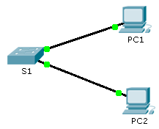
Addressing Table
Device | Interface | IP Address | Subnet Mask
S1 | VLAN 1 | 10.10.10.2 | 255.255.255.0
PC1 | NIC | 10.10.10.10 | 255.255.255.0
PC2 | NIC | 10.10.10.11 | 255.255.255.0
Scenario
The network administrator asked you to configure a new switch. In this activity, you will use a list of requirements to configure the new switch with initial settings, SSH, and port security.
Requirements
- Configure S1 with the following initial settings:
Hostname
Banner that includes the word warning
Console port login and password cisco
Encrypted enable password of class
Encrypt plain text passwords
Management interface addressing
- Configure SSH to secure remote access with the following settings:
Domain name of cisco.com
RSA key-pair parameters to support SSH version 2
Set SSH version 2
User admin with secret password ccna
VTY lines only accept SSH connections and use local login for authentication
- Configure the port security feature to restrict network access:
Disable all unused ports.
Set the interface mode to access.
Enable port security to allow only two hosts per port.
Record the MAC address in the running configuration.
Ensure that port violations disable ports.

