Packet Tracer – Verifying and Troubleshooting NAT Configurations
Topology
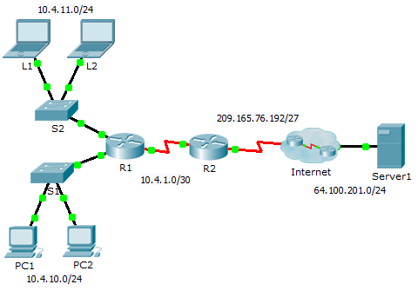
Addressing Table
Device | Interface | IP Address | Subnet Mask | Default Gateway
R1 | G0/0 | 10.4.10.254 | 255.255.255.0 | N/A
 | G0/1 | 10.4.11.254 | 255.255.255.0 | N/A
 | S0/0/1 | 10.4.1.2 | 255.255.255.252 | N/A
R2 | S0/0/0 | 209.165.76.194 | 255.255.255.224 | N/A
 | S0/0/1 | 10.4.1.1 | 255.255.255.252 | N/A
Server1 | NIC | 64.100.201.5 | 255.255.255.0 | 64.100.201.1
PC1 | NIC | 10.4.10.1 | 255.255.255.0 | 10.4.10.254
PC2 | NIC | 10.4.10.2 | 255.255.255.0 | 10.4.10.254
L1 | NIC | 10.4.11.1 | 255.255.255.0 | 10.4.11.254
L2 | NIC | 10.4.11.2 | 255.255.255.0 | 10.4.11.254
Objectives
Part 1: Isolate Problems
Part 2: Troubleshoot NAT Configuration
Part 3: Verify Connectivity
Scenario
A contractor restored an old configuration to a new router running NAT. But, the network has changed and a new subnet was added after the old configuration was backed up. It is your job to get the network working again.
- Isolate Problems
Ping Server1 from PC1, PC2, L1, L2, and R2. Record the success of each ping. Ping any other machines as needed.
- Troubleshoot NAT Configuration
  - View the NAT translations on R2.
If NAT is working, there should be table entries.
  - Show the running configuration of R2.
The NAT inside port should align with the private address, while the NAT outside port should align with the public address.
  - Correct the Interfaces.
Assign the ip nat inside and ip nat outside commands to the correct ports.
  - Ping Server1 from PC1, PC2, L1, L2, and R2.
Record the success of each ping. Ping any other machines as needed.
  - View the NAT translations on R2.
If NAT is working, there should be table entries.
  - Show Access-list 101 on R2.
The wildcard mask should encompass both the 10.4.10.0 network and the 10.4.11.0 network.
  - Correct the Access-list.
Delete access-list 101 and replace it with a similar list that is also one statement in length. The only difference should be the wildcard.
- Verify Connectivity
  - Verify connectivity to Server1.
Record the success of each ping. All hosts should be able to ping Server1, R1, and R2. Troubleshoot if the pings are not successful.
  - View the NAT translations on R2.
NAT should display many table entries.

