Packet Tracer - Troubleshooting a VLAN Implementation Scenario 1
Topology
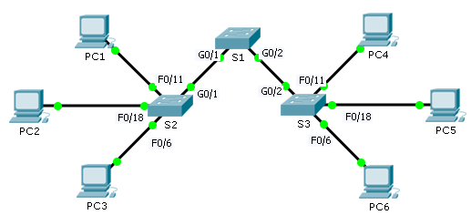
Addressing Table
Device | Interface | IPv4 Address | Subnet Mask | Switch Port | VLAN
PC1 | NIC | 172.17.10.21 | 255.255.255.0 | S1 F0/11 | 10
PC2 | NIC | 172.17.20.22 | 255.255.255.0 | S1 F0/18 | 20
PC3 | NIC | 172.17.30.23 | 255.255.255.0 | S1 F0/6 | 30
PC4 | NIC | 172.17.10.24 | 255.255.255.0 | S2 F0/11 | 10
PC5 | NIC | 172.17.20.25 | 255.255.255.0 | S2 F0/18 | 20
PC6 | NIC | 172.17.30.26 | 255.255.255.0 | S2 F0/6 | 30
Objectives
Part 1: Test Connectivity between PCs on the Same VLAN
Part 2: Investigate Connectivity Problems by Gathering Data
Part 3: Implement the Solution and Test Connectivity
Scenario
In this activity, you will troubleshoot connectivity problems between PCs on the same VLAN. The activity is complete when PCs on the same VLAN can ping each other. Any solution you implement must conform to the Addressing Table.

- Test Connectivity between PCs on the Same VLAN
From the command prompt on each PC, ping between PCs on the same VLAN.
    - Can PC1 ping PC4? ____________
    - Can PC2 ping PC5? ____________
    - Can PC3 ping PC6? ____________
- Investigate Connectivity Problems by Gathering Data
  - Verify configuration on the PCs.
Verify if the following configurations for each PC is correct.
- IP address
- Subnet mask
  - Verify the configuration on the switches.
Verify if the following configurations on the switches are correct.
- Ports assigned to the correct VLANs.
- Ports configured for the correct mode.
- Ports connected to the correct devices.
  - Document the problem and the solutions.
List the problems and the solutions that will allow these PCs to ping each other. Keep in mind that there could be more than one problem or more than one solution.
PC1 to PC4
    - Explain the connectivity issues between PC1 and PC4.
____________________________________________________________________________________
    - Record the necessary actions to correct the issues.
____________________________________________________________________________________
____________________________________________________________________________________
PC2 to PC5
    - Explain the connectivity issues between PC2 and PC5.
____________________________________________________________________________________
    - Record the necessary actions to correct the issues.
____________________________________________________________________________________
____________________________________________________________________________________
PC3 to PC6
    - What are the reasons why connectivity failed between the PCs?
____________________________________________________________________________________
____________________________________________________________________________________
    - Record the necessary actions to correct the issues.
____________________________________________________________________________________
____________________________________________________________________________________
- Implement the Solution and Test Connectivity
Verify PCs on the same VLAN can now ping each other. If not, continue to troubleshoot.
Suggested Scoring Rubric
Packet Tracer scores 70 points. Documentation in Part 2, Step 3 is worth 30 points.

