Packet Tracer – Inter-VLAN Routing Challenge
Topology
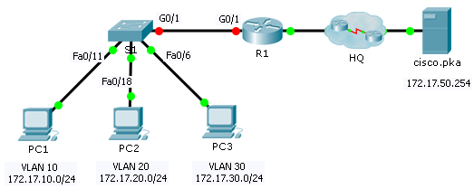
Addressing Table
Device | Interface | IP Address | Subnet Mask | Default Gateway
R1 | G0/0 | 172.17.25.2 | 255.255.255.252 | N/A
 | G0/1.10 | 172.17.10.1 | 255.255.255.0 | N/A
 | G0/1.20 | 172.17.20.1 | 255.255.255.0 | N/A
 | G0/1.30 | 172.17.30.1 | 255.255.255.0 | N/A
 | G0/1.88 | 172.17.88.1 | 255.255.255.0 | N/A
 | G0/1.99 | 172.17.99.1 | 255.255.255.0 | N/A
S1 | VLAN 99 | 172.17.99.10 | 255.255.255.0 | 172.17.99.1
PC1 | NIC | 172.17.10.21 | 255.255.255.0 | 172.17.10.1
PC2 | NIC | 172.17.20.22 | 255.255.255.0 | 172.17.20.1
PC3 | NIC | 172.17.30.23 | 255.255.255.0 | 172.17.30.1
VLAN and Port Assignments Table
VLAN | Name | Interface
10 | Faculty/Staff | Fa0/11-17
20 | Students | Fa0/18-24
30 | Guest(Default) | Fa0/6-10
88 | Native | G0/1
99 | Management | VLAN 99
Scenario
In this activity, you will demonstrate and reinforce your ability to implement inter-VLAN routing, including configuring IP addresses, VLANs, trunking and subinterfaces.
Requirements
- Assign IP addressing to R1 and S1 based on the Addressing Table.
- Create, name and assign VLANs on S1 based on the VLAN and Port Assignments Table. Ports should be in access mode.
- Configure S1 to trunk, allow only the VLANs in the VLAN and Port Assignments Table.
- Configure the default gateway on S1.
- All ports not assigned to a VLAN should be disabled.
- Configure inter-VLAN routing on R1 based on the Addressing Table.
- Verify connectivity. R1, S1, and all PCs should be able to ping each other and the cisco.pka server.

