Packet Tracer - Configuring IPv4 Static and Default Routes
Topology
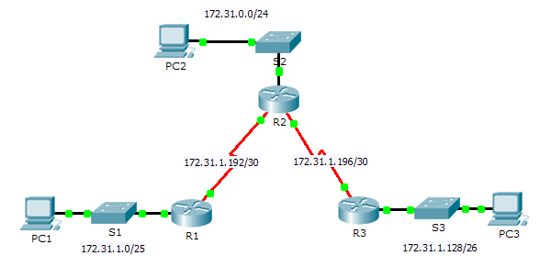
Addressing Table
Device | Interface | IPv4 Address | Subnet Mask | Default Gateway
R1 | G0/0 | 172.31.1.1 | 255.255.255.128 | N/A
 | S0/0/0 | 172.31.1.194 | 255.255.255.252 | N/A
R2 | G0/0 | 172.31.0.1 | 255.255.255.0 | N/A
 | S0/0/0 | 172.31.1.193 | 255.255.255.252 | N/A
 | S0/0/1 | 172.31.1.197 | 255.255.255.252 | N/A
R3 | G0/0 | 172.31.1.129 | 255.255.255.192 | N/A
 | S0/0/1 | 172.31.1.198 | 255.255.255.252 | N/A
PC1 | NIC | 172.31.1.126 | 255.255.255.128 | 172.31.1.1
PC2 | NIC | 172.31.0.254 | 255.255.255.0 | 172.31.0.1
PC3 | NIC | 172.31.1.190 | 255.255.255.192 | 172.31.1.129
Objectives
Part 1: Examine the Network and Evaluate the Need for Static Routing
Part 2: Configure Static and Default Routes
Part 3: Verify Connectivity
Background
In this activity, you will configure static and default routes. A static route is a route that is entered manually by the network administrator to create a reliable and safe route. There are four different static routes that are used in this activity: a recursive static route, a directly attached static route, a fully specified static route, and a default route.
- Examine the Network and Evaluate the Need for Static Routing
    - Looking at the topology diagram, how many networks are there in total? _____________
    - How many networks are directly connected to R1, R2, and R3? _________________________________
    - How many static routes are required by each router to reach networks that are not directly connected?
____________________________________________________________________________________
    - Test connectivity to the R2 and R3 LANs by pinging PC2 and PC3 from PC1.
Why were you unsuccessful? ____________________________________________________________
- Configure Static and Default Routes
  - Configure recursive static routes on R1.
    - What is recursive static route?
____________________________________________________________________________________
____________________________________________________________________________________
    - Why does a recursive static route require two routing table lookups?
____________________________________________________________________________________
____________________________________________________________________________________
    - Configure a recursive static route to every network not directly connected to R1, including the WAN link between R2 and R3.
    - Test connectivity to the R2 LAN and ping the IP addresses of PC2 and PC3.
Why were you unsuccessful?
____________________________________________________________________________________
  - Configure directly attached static routes on R2.
    - How does a directly attached static route differ from a recursive static route?
____________________________________________________________________________________
____________________________________________________________________________________
    - Configure a directly attached static route from R2 to every network not directly connected.
    - Which command only displays directly connected networks? ___________________________________
    - Which command only displays the static routes listed in the routing table? _________________________
    - When viewing the entire routing table, how can you distinguish between a directly attached static route and a directly connected network?
____________________________________________________________________________________
  - Configure a default route on R3.
    - How does a default route differ from a regular static route?
____________________________________________________________________________________
____________________________________________________________________________________
____________________________________________________________________________________
    - Configure a default route on R3 so that every network not directly connected is reachable.
    - How is a static route displayed in the routing table? _________________________
  - Document the commands for fully specified routes.
Note: Packet Tracer does not currently support configuring fully specified static routes. Therefore, in this step, document the configuration for fully specified routes.
    - Explain a fully specified route.
____________________________________________________________________________________
____________________________________________________________________________________
    - Which command provides a fully specified static route from R3 to the R2 LAN?
____________________________________________________________________________________
    - Write a fully specified route from R3 to the network between R2 and R1. Do not configure the route; just calculate it.
____________________________________________________________________________________
    - Write a fully specified static route from R3 to the R1 LAN. Do not configure the route; just calculate it.
____________________________________________________________________________________
  - Verify static route configurations.
Use the appropriate show commands to verify correct configurations.
Which show commands can you use to verify that the static routes are configured correctly?
____________________________________________________________________________________
- Verify Connectivity
Every device should now be able to ping every other device. If not, review your static and default route configurations.
Suggested Scoring Rubric
Activity Section | Question Location | Possible Points | Earned Points
Part 1: Examine the Network and Evaluate the Need for Static Routing | a - d | 10
Part 1 Total |  | 10
Part 2: Configure Static and Default Routes | Step 1 | 7
 | Step 2 | 7
 | Step 3 | 3
 | Step 4 | 10
 | Step 5 | 3
Part 2 Total |  | 30
Packet Tracer Score |  | 60
Total Score |  | 100

