Packet Tracer - Troubleshooting Switch Port Security
Topology
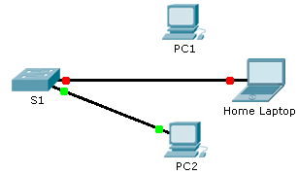
Scenario
The employee who normally uses PC1 brought his laptop from home, disconnected PC1 and connected the laptop to the telecommunication outlet. After reminding him of the security policy that does not allow personal devices on the network, you now must reconnect PC1 and re-enable the port.
Requirements
- Disconnect Home Laptop and reconnect PC1 to the appropriate port.
When PC1 was reconnected to the switch port, did the port status change? ____________
Enter the command to view the port status. What is the state of the port?
________________________________________________________________________________
Which port security command enabled this feature?
________________________________________________________________________________
- Enable the port using the necessary command.
- Verify connectivity. PC1 should now be able to ping PC2.
Suggested Scoring Rubric
Packet Tracer scores 90 points. Answers to the questions are worth 10 points.

