Packet Tracer – Configuring Syslog and NTP
Topology
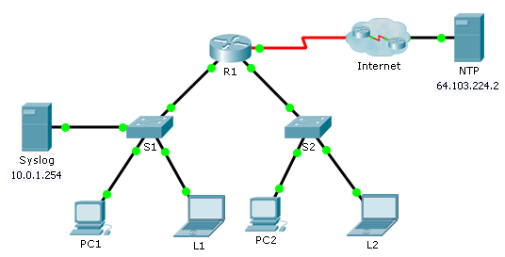
Objectives
Part 1: Configure Syslog Service
Part 2: Generate Logged Events
Part 3: Manually Set Switch Clocks
Part 4: Configure NTP Service
Part 5: Verify Timestamped Logs
Scenario
In this activity, you will enable and use the Syslog service and the NTP service so that the network administrator is able to monitor the network more effectively.
- Configure Syslog Service
  - Enable the Syslog service.
    - Click Syslog, then Services tab.
    - Turn the Syslog service on and move the window so you can monitor activity.
  - Configure the intermediary devices to use the Syslog service.
    - Configure R1 to send log events to the Syslog server.
R1(config)# logging 10.0.1.254
    - Configure S1 to send log events to the Syslog server.
    - Configure S2 to send log events to the Syslog server.
- Generate Logged Events
  - Change the status of interfaces to create event logs.
    - Configure a Loopback 0 interface on R1 then disable it.
    - Turn off PC1 and PC2. Turn them on again.
  - Examine the Syslog events.
    - Look at the Syslog events. Note: All of the events have been recorded; however, the time stamps are incorrect.
    - Clear the log before proceeding to the next part.
- Manually Set Switch Clocks
  - Manually set the clocks on the switches.
Manually set the clock on S1 and S2 to the current date and approximate time. An example is provided.
S1# clock set 11:47:00 July 10 2013
  - Enable the logging timestamp service on the switches.
Configure S1 and S2 to send its timestamp with logs it sends to the Syslog server.
S1(config)# service timestamps log datetime msec
- Configure NTP Service
  - Enable the NTP service.
In this activity, we are assuming that the NTP service is being hosted on a public Internet server. If the NTP server was private, authentication could also be used.
    - Open the Services tab of the NTP server.
    - Turn the NTP service on and note the date and time that is displayed.
  - Automatically set the clock on the router.
Set the clock on R1 to the date and time according to the NTP server.
R1(config)# ntp server 64.103.224.2
  - Enable the logging timestamp service of the router.
Configure R1 to send its timestamp with the logs that it sends to the Syslog server.
- Verify Timestamped Logs
  - Change the status of interfaces to create event logs.
    - Re-enable and then disable the Loopback 0 interface on R1.
    - Turn off laptops L1 and L2. Turn them on again.
  - Examine the Syslog events.
Look at the Syslog events. Note: All of the events have been recorded and the time stamps are correct as configured. Note: R1 uses the clock settings from the NTP server, and S1 and S2 use the clock settings configured by you in Part 3.

