Packet Tracer - Documenting the Network
Topology
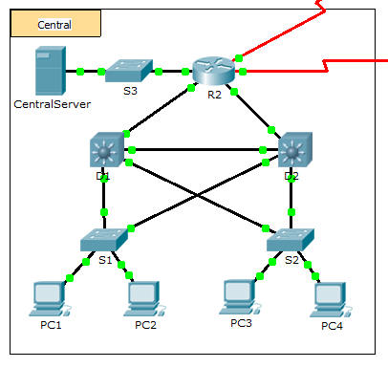
Background
In this activity, your job is to document the addressing scheme and connections used in the Central portion of the network. You must use a variety of commands to gather the required information.
Note: The user EXEC password is cisco. The privileged EXEC password is class.
Requirements
- Access the command line of the various devices in Central.
- Use commands to gather the information required in the Addressing Scheme and Device Connection Documentation table.
- If you do not remember the necessary commands, you can use the IOS built-in help system.
- If you still need additional hints, refer to the Hints page. In Packet Tracer, click the right arrow (>) on the bottom right side of the instruction window. If you have a printed version of the instructions, the Hints page is the last page.

Addressing Scheme and Device Connection Documentation
Device Name | Interface | Address | Subnet Mask | Connecting Device
 |  |  |  | Device Name | Interface
R2 | G0/0
 | G0/1
 | G0/2
 | S0/0/0 | 64.100.100.1 | 255.255.255.252 | Internet | N/A
 | S0/0/1.1 | 64.100.200.2 | 255.255.255.252 | Intranet | N/A
S3 | VLAN 1 | 10.10.10.254 | 255.255.255.0 | N/A | N/A
 | F0/1 | N/A | N/A | CentralServer | NIC
 | G0/1 | N/A | N/A
CentralServer | NIC
D1 | VLAN2 | 10.2.0.1 | 255.255.255.0 | N/A | N/A
 | G0/1
 | G0/2
 | F0/23 | N/A | N/A
 | F0/24 | N/A | N/A
S1 | VLAN 2 | 10.2.0.2 | 255.255.255.0 | N/A | N/A
 | F0/23 | N/A | N/A
 | G0/1 | N/A | N/A
D2 | F0/23 | N/A | N/A | S1 | F0/23
 | F0/24
 | G0/1
 | G0/2
S2 | VLAN 1 | 10.3.0.2 | 255.255.255.0 | N/A | N/A
 | F0/23 | N/A | N/A
 | G0/1 | N/A | N/A

Hints
Use the following commands to gather the information you need to document the network:
show ip interface brief
show interfaces
show running-config
ipconfig

