Packet Tracer – Investigating NAT Operation
Topology
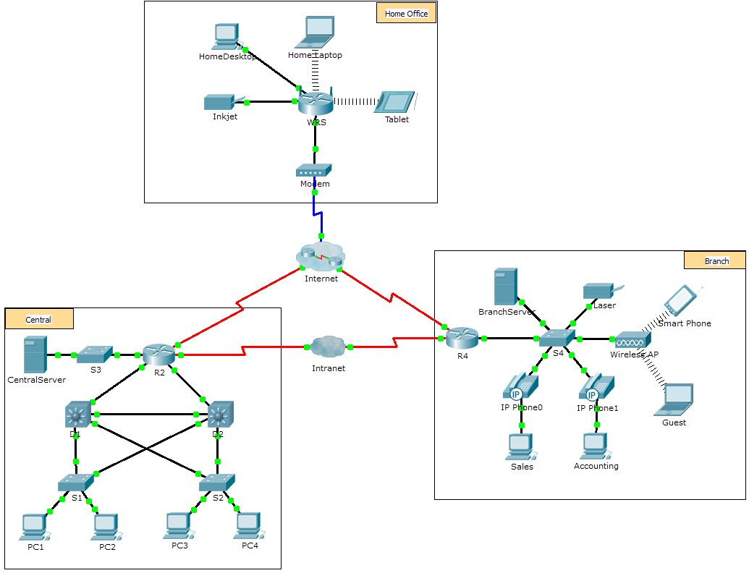
Objectives
Part 1: Investigate NAT Operation Across the Intranet
Part 2: Investigate NAT Operation Across the Internet
Part 3: Conduct Further Investigations
Scenario
As a frame travels across a network, the MAC addresses may change. IP addresses can also change when a packet is forwarded by a device configured with NAT. In this activity, we will investigate what happens to IP addresses during the NAT process.
- Investigate NAT Operation Across the Intranet
  - Wait for the network to converge.
It might take a few minutes for everything in the network to converge. You can speed the process up by clicking on Fast Forward Time.
  - Generate an HTTP request from any PC in the Central domain.
    - Open the Web Browser of any PC in the Central domain and type the following without pressing enter or clicking Go: http://branchserver.pka.
    - Switch to Simulation mode and edit the filters to show only HTTP requests.
    - Click Go in the browser, a PDU envelope will appear.
    - Click Capture / Forward until the PDU is over D1 or D2. Record the source and destination IP addresses. To what devices do those addresses belong?
____________________________________________________________________________________
____________________________________________________________________________________
    - Click Capture / Forward until the PDU is over R2. Record the source and destination IP addresses in the outbound packet. To what devices do those addresses belong?
____________________________________________________________________________________
____________________________________________________________________________________
    - Login to R2 using ‘class’ to enter privileged EXEC and show the running configuration. The address came from the following address pool:
ip nat pool R2Pool 64.100.100.3 64.100.100.31 netmask 255.255.255.224
    - Click Capture / Forward until the PDU is over R4. Record the source and destination IP addresses in the outbound packet. To what devices do those addresses belong?
____________________________________________________________________________________
____________________________________________________________________________________
    - Click Capture / Forward until the PDU is over Branserver.pka. Record the source and destination TCP port addresses in the outbound segment.
    - On both R2 and R4, run the following command and match the IP addresses and ports recorded above to the correct line of output:
R2# show ip nat translations
R4# show ip nat translations
    - What do the inside local IP addresses have in common? ______________________________________
    - Did any private addresses cross the Intranet? ______________
    - Return to Realtime mode.
- Investigate NAT Operation Across the Internet
  - Generate an HTTP request from any computer in the home office.
    - Open the Web Browser of any computer in the home office and type the following without pressing enter or clicking Go: http://centralserver.pka.
    - Switch to Simulation mode. The filters should already be set to show only HTTP requests.
    - Click Go in the browser, a PDU envelope will appear.
    - Click Capture / Forward until the PDU is over WRS. Record the inbound source and destination IP addresses and the outbound source and destination addresses. To what devices do those addresses belong?
____________________________________________________________________________________
____________________________________________________________________________________
    - Click Capture / Forward until the PDU is over R2. Record the source and destination IP addresses in the outbound packet. To what devices do those addresses belong?
____________________________________________________________________________________
    - On R2, run the following command and match the IP addresses and ports recorded above to the correct line of output:
R2# show ip nat translations
    - Return to Realtime mode. Did all of the web pages appear in the browsers? ______________
- Conduct Further Investigations
    - Experiment with more packets, both HTTP and HTTPS. There are many questions to consider such as:
- Do the NAT translation tables grow?
- Does WRS have a pool of addresses?
- Is this how the computers in the classroom connect to the Internet?
- Why does NAT use four columns of addresses and ports?
Suggested Scoring Rubric
Activity Section | Question Location | Possible Points | Earned Points
Part 1: Request a Web Page Across the Intranet | Step 2d | 12
 | Step 2e | 12
 | Step 2g | 13
 | Step 2j | 12
 | Step 2k | 12
Part 1 Total |  | 61
Part 2: Request a Web Page Across the Internet | Step 1d | 13
 | Step 1e | 13
 | Step 1g | 13
Part 2 Total |  | 39
Total Score |  | 100

