Packet Tracer – Troubleshooting a VLAN Implementation Scenario 2
Topology
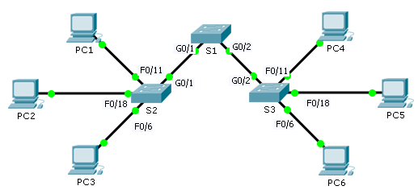
Addressing Table
Device | Interface | IPv4 Address | Subnet Mask | Default Gateway
S1 | VLAN 56 | 192.168.56.11 | 255.255.255.0 | N/A
S2 | VLAN 56 | 192.168.56.12 | 255.255.255.0 | N/A
S3 | VLAN 56 | 192.168.56.13 | 255.255.255.0 | N/A
PC1 | NIC | 192.168.10.21 | 255.255.255.0 | 192.168.10.1
PC2 | NIC | 192.168.20.22 | 255.255.255.0 | 192.168.20.1
PC3 | NIC | 192.168.30.23 | 255.255.255.0 | 192.168.30.1
PC4 | NIC | 192.168.10.24 | 255.255.255.0 | 192.168.10.1
PC5 | NIC | 192.168.20.25 | 255.255.255.0 | 192.168.20.1
PC6 | NIC | 192.168.30.26 | 255.255.255.0 | 192.168.30.1
VLAN and Port Assignments
Ports | VLAN Number - Name | Network
F0/1 – F0/5 | VLAN 56 – Management&Native | 192.168.56.0/24
F0/6 – F0/10 | VLAN 30 – Guest(Default) | 192.168.30.0/24
F0/11 – F0/17 | VLAN 10 – Faculty/Staff | 192.168.10.0/24
F0/18 – F0/24 | VLAN 20 – Students | 192.168.20.0/24

Objectives
Part 1: Find and Correct the Network Errors
Part 2: Document the Corrections to the Network
Part 3: Implement Solutions and Test Connectivity
Background
In this activity, you will troubleshoot a misconfigured VLAN environment. The initial network has errors. Your objective is to locate and correct the errors in the configurations and establish end-to-end connectivity. Your final configuration should match the Topology diagram and Addressing Table. The native VLAN for this topology is VLAN 56.
- Discover and Document Issues in the Network
Use the Topology, Addressing Table, VLAN and Port Assignments table and your knowledge of VLANs and trunking to discover issues in the network. Complete the Documentation table listing the problems you discovered and potential solutions.
Documentation
Problems | Solutions
- Implement the Solution and Test Connectivity
Verify PCs on the same VLAN can now ping each other. If not, continue to troubleshoot.
Suggested Scoring Rubric
Packet Tracer scores 70 points. Documentation in Part 2, Step 3 is worth 30 points.

